***Type: xxx***

**Covid-19 Infection Percentage Estimation Using Deep Learning**

**Asif Ibn Zayed1,** **Md. Jobayer Hossain Chowdhury1, Nadia Binte Rahman 1, Mohammad Monirujjaman Khan1**

1Department of Electrical and Computer Engineering, North South University, Bashundhara, Dhaka-1229, Bangladesh

*Corresponding Author: Mohammad Monirujjaman Khan

Email: monirujjaman.khan@northsouth.edu

**Abstract:** COVID-19 is a contagious disease that has spread worldwide, resulting in a pandemic caused by the severe acute respiratory syndrome coronavirus 2 (SARS-CoV-2). In December of 2019, the first known case was discovered in Wuhan, China. Since then, the disease has spread worldwide, resulting in a pandemic. Within a few months, the entire world had been affected. The SARS-CoV-2 virus can infect a wide range of cells and systems in the body. COVID-19 is most known for its effects on the sinuses, nose, and throat, as well as the lower respiratory tract, which includes the windpipe and lungs. The lungs are the organs most affected by COVID-19. In this paper, we aimed to estimate the percentage of lung infections due to COVID-19 using deep learning methods. To estimate this, we used the lung image dataset from Codalab. The dataset contains X-ray, computerized tomography (CT) scans, and ultrasonic images. TensorFlow and other machine learning tools were used to create and train neural networks in this study. Conv2D, Dense Net, Dropout, and Maxpooling2D are some of the deep learning features utilized to create the model. We applied a pre-trained deep convolutional neural network such as VGG19. We obtained a 75.82% validation accuracy from the model. We will try to increase the accuracy of the system in 499B by using transfer learning.

**Keywords:** COVID-19; CNN; Python; chest CT; dataset; data augmentation; VGG19

**1 Introduction**

Coronavirus disease 2019, or COVID-19, is a contagious disease caused by the severe acute respiratory syndrome coronavirus 2 (SARS-CoV-2). In December of 2019, the first known A case was discovered in Wuhan, China [1]. Since then, the disease has spread worldwide, resulting in a pandemic. The virus and disease were identified as "coronavirus" and "Wuhan coronavirus" during the original outbreak in Wuhan [2]. Sometimes it is called "Wuhan pneumonia." In January 2020, 2019-nCoV [3] and 2019-nCoV [4] acute respiratory diseases were recommended by the WHO. According to world meter statistics, by now the world has lost 5,273,756 lives due to COVID-19, and humans were helpless in front of this. The world government took many initiatives to prevent the spread of the disease. Many countries go through lockdown situations. International borders were closed several times due to COVID-19. In 2020, the FTSE fell by 14.3%, the lowest rate since 2008 [5]. Many people have lost their jobs or had their salaries reduced. Across the board, unemployment rates have risen. Also, much research is occurring in many sectors to find an efficient way to prevent the loss. Researchers in computer science have done many good things, such as predicting COVID in various ways. They have used machine learning and deep learning to predict COVID.

The impact on the investigations into the COVID-19 case was immediate, emotional, and undeniably long-lasting. The majority of scholarly, business, and government fundamental research and clinical investigations have been reduced or have already been diverted to COVID-19. The majority of ongoing clinical trials, including those looking for life-saving cures, have been postponed, and the majority of those still open to modern recruitment have closed. Continuous clinical trials have been modified to allow domestic organizations to provide care and virtual monitoring, reducing the risk of COVID-19 contamination and avoiding diverting healthcare resources away from a widespread reaction. COVID-19 can be identified based on symptoms and then validated by RT-PCR or other nucleic acid tests of contaminated secretions [6]. Chest CT scans, in addition to laboratory tests, may be useful in diagnosing COVID-19 in people who have a strong clinical suspicion of infection [7]. Serological tests that identify antibodies produced This is used by the body in response to infection and can be used to diagnose a previous infection [6]. There is a lot of research that uses X-ray and CT to predict COVID. This is an efficient way to predict COVID infection. So that type of deep learning-based prediction system may reduce the price and allow a patient to be predicted.

Recognizing COVID-19 infection is a critical step in combating the COVID-19 pandemic. The Reverse Transcription Polymerase Chain Reaction (RT-PCR), X-ray scan, and computed tomography (CT-scan) scan have all been used to detect COVID19 infection. One paper has got 98.33% accuracy in predicting COVID-19 from the X-Ray pictures [8]. They used Conv2D, Dense Net, Dropout, and Maxpooling2D to create the model. Another paper also obtained 98% accuracy using the same X-ray data by the InceptionV3 model [9]. In addition, CT scans can provide further information regarding the progression of the disease and its severity, in addition to recognizing the COVID-19 infection. With such a large number of COVID-19 infections, determining the COVID-19 percentage can help intensive care in freeing up ICU beds for critical cases while following alternate protocols for cases of lower severity. Inception-v3 achieved the following slice-level results using the Dynamic Huber loss function and pretrained models using X-ray data: 0.9365, 0.9365, 0.9365, 0.9365, 0.9365, 0.9365, 0.9365, 0.9365, 0.9365, 0.9365, 0.9365, 0.9365, Pearson Correlation coefficient (PC), Mean Absolute Error (MAE), and Root Mean Square Error (RMSE) are 5.10 and 9.25, respectively [10]. In the last 2 years, lots of research work has been done on the prediction of COVID-19 and they have achieved very nice results. But no work has been done on the COVID-19 infection. Percentage Estimation Our goal is to use X-ray, CT-scans, and ultrasound images to estimate the infarction percentage.

There has been very little work in estimating lung infection due to COVID; previously, most papers were about COVID-19 prediction, so our goal is to achieve high accuracy using the VGG-19 model. The obtained accuracy is 75.82 %. Our primary goal is to achieve the highest accuracy rate for the prediction of the input images. This will guarantee that the output is credible and can be trusted. With the dataset being used, the primary goal is the accuracy rate. Different methods have been used to increase the accuracy, as explained further in this paper.

Section one provides an introduction. In section two, methods and methodology are described. In section three, mathematical equations and expressions are presented. The results are provided in section four. A performance comparison is shown in section five. Finally, section six discusses the conclusion.

**2 Method and Methodology**

The proposed system aims to estimate the COVID infection from lung images using deep learning. The available dataset [11,12] was collected from codalab and github and then merged to prepare a suitable dataset. The dataset contains the CT scans of the lungs of normal and affected people.

The model has four Conv2D layers, three MaxPooling2D layers, one flattened layer, two dense layers, and a rectified linear unit (ReLU) activation function. The final dense layer, softmax, was used as the activation function. In this study, transfer learning is also used so that the accuracy of the designed model can be compared with that of the pretrained model. For the pretrained model, VGG19 is used, with some modifications in the final layers, and a head model from the base model. The customized final layers are average pooling, flattening, dense, and dropout. The CNN model is suitable for image feature extraction as it extracts the features of given images and learns and differentiates the images based on these features.

***2.1Outline of Full System***

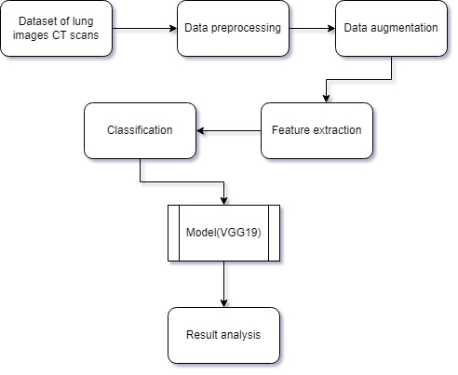

Fig 1 shows the block diagram of whole system

The system is made up of a dataset that includes Covid patients’ lung CT scan images. From the CT scans, we did some data preprocessing and data augmentation. Data augmentation methods on CNN utilize Tensorflow and Keras. Then we fed the data into our model and analyzed the output.

***2.2 Materials and Tools***

Python is an excellent data analysis programming language. Because of Python's large library access, deep learning-based challenges are particularly effective. Using a personal GPU for dataset preprocessing, Jupyter Notebook, as well as Google Colab, were used to handle large datasets and model training online. They were also used to save all data, code, and work in order for it to be retrieved from any GPU using GitHub. Because GitHub has a teamwork and code management tracking system, it is also suitable for teamwork.

***2.3 Dataset Description***

The available dataset [11,12] was collected from codalab and github. There are three parts to the dataset: train, value, and test. The train set is made up of 132 CT scans, 128 of which have been verified to have COVID-19 based on positive reverse transcription polymerase chain reaction (RT-PCR) results and CT scan manifestations evaluated by two thoracic radiologists. The other four CT scans show no signs of infection (healthy). The Val set is made up of 57 CT scans, 55 of which have been verified to have Covid-19 based on positive reverse transcription polymerase chain reaction (RT-PCR) results and CT scan manifestations evaluated by two thoracic radiologists. The other two CT scans show no signs of infection (healthy). Each CT scan consists of 40–70 slices.Those CT scans are split into 3053 images. It also contains the labeling data as a csv file.In this study, we augmented the data. Data augmentation has been used to increase data diversity while avoiding the collection of new data.

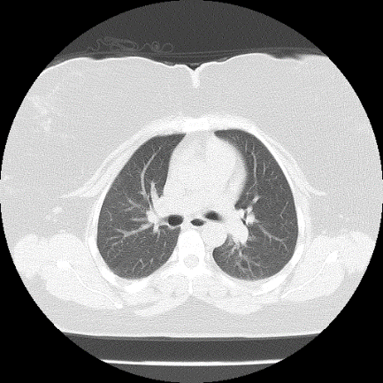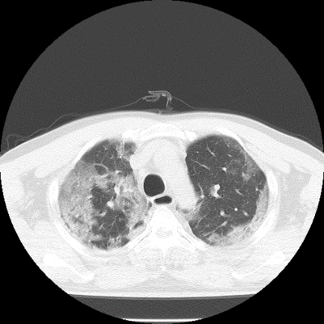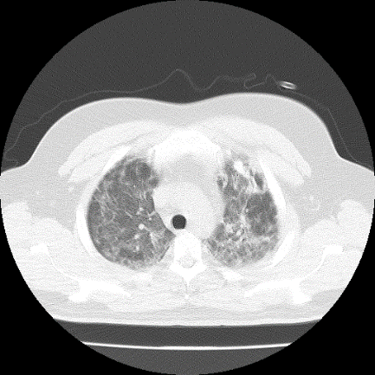

Figure 2: 0% to 100% infected lungs image

Left most lungs is 0% affected Middle lungs is 55% affected and the right most lungs is 97% affected.

***2.4 System Architecture***

The system architecture is a high-level overview of the complete system.In this architecture the input is a CT scan image and the output is a estimation of infection .The input shape is 128 * 128,and there are three channels.

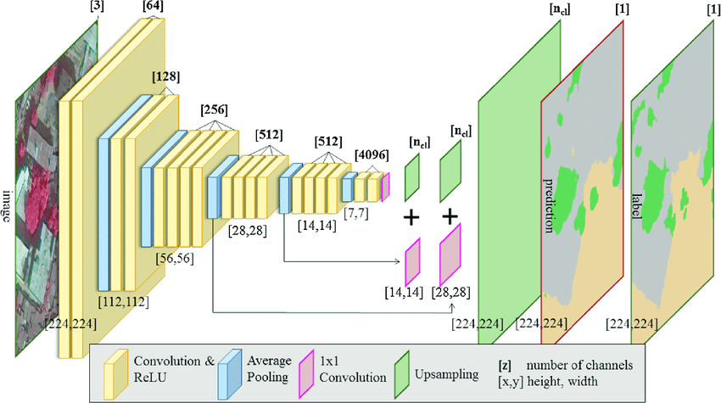

**Figure 3:** System Architecture

***2.4.1 Convolutional Layer***

CNN's basic layer is the convolutional layer. This is in charge of determining the design features. In this layer, the input image is processed by a filter. Convolution is used to obtain the function map from the output of the same filters. A convolution operation performs the multiplication of weight sets with the input. A filter is made up of a two-dimensional array of weights multiplied by an array of input data. A dot product is a type of multiplication that results in a single value when applied between a filter-sized patch of the input and the filter. This product is used between the input's filter-sized patch and the filter.

The filter is smaller than the input, and the same filter is used to multiply the input from different points. The filter is designed as a special technique to identify specific types of features as it systematically covers the entire image.Assume that the NN input is, where A denotes the number of features that indicate an input frequency band and B denotes the total number of input frequency bands. The size of the filter bank function vector is represented by B in the case of filter bank features. Assume that v = [v1] [v2] [vB], where vB is the function vector for band b. The activations of the convolution layer can be calculated as where is the feature map’s convolution layer output of the convolution layer band, s indicates the filter scale, indicates the weight vector for the filter’s back band, is the feature map's bias, and (x) represents the activation function [13].

***2.4.2 Pooling Layer***

The pooling layer summarizes the presence of features by allowing for feature downsampling. It has some spatial invariance and is typically used after a convolution layer. Average pooling and maximum pooling are two popular pooling methods that summarize the average presence of a function and the most activated presence of a function [14].

In fact, the pooling layer removes unnecessary features from the images and converts them into literate images. Every time the layer uses average pooling, it averages the value of its current view. When max pooling is used, the layer always selects the maximum value from the filter's current view. The max-pooling technique selects only the maximum value using the matrix size specified in each feature map, resulting in fewer output neurons. As a result, the image shrinks dramatically, but the scenario remains unchanged.A pooling layer is necessary to reduce the number of feature maps and network parameters, while a dropout layer is used to prevent overfitting.

The activation of max pooling can be calculated as follows: where is the performance of the pooling layer of the jth function map and the mth pooling layer band, n is the subsampling factor, r is the pooling scale, and n is the subsampling factor.

***2.4.3 Flatten Layer***

The flattened layer is used to convert matrix data into a one-dimensional array for use in the fully connected layer, as well as to create a single one-dimensional feature that is both long and narrow. Vector flattening is an option. Finally, it links the single vector to the final classification model, also known as a fully connected layer [15]. All pixel data is provided in a single file and is linked with fully connected layers. CNN's final steps are flattening and fully connecting the layers. It is converted into a one-dimensional array in preparation for the next fully linked layer of image categorization.

***2.4.3 Fully Connected Layer***

CNNs rely heavily on fully connected layers, which have proven to be quite useful in image recognition and classification in computer vision. The CNN process begins with convolution and pooling, which divides the image into attributes and analyzes them separately [16].

Each input in a fully connected layer is connected to all neurons, and the inputs are flattened. As a fully connected layer, the ReLU activation function is commonly used. In the final layer of the fully connected layer, the softmax activation function was used to predict the output images. A fully connected layer is used in the convolutional neural network architecture. These are the convolutional neural network's final and most important layers.

***2.4.3 Pretrained Models***

One of the most difficult challenges for researchers in medical-related research is the scarcity of medical data or datasets, and data is one of the most important components of deep learning approaches. Data analysis and labeling are both time-consuming and expensive. Transfer learning has the advantage of not necessitating the use of large datasets. The calculations become simpler and less expensive. Transfer learning is a method in which the pre-trained model, which was trained on a large dataset, is transferred to the new model that needs to be trained, including new data that is smaller than what is needed. For a specific task, this process started the CNN training with a small dataset, which included a large-scale dataset that had already been trained in the pre-trained models [17].

VGG 19 is use to classify the images in CT scan images .

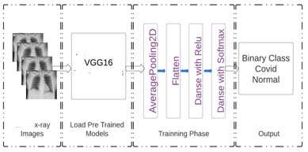

**Figure 4:** System architecture of the pre-trained model

**4 Result and analysis**

After training the model with the train generator, validation generator, our model provided 75.82% accuracy in the 16th epoch of our model.

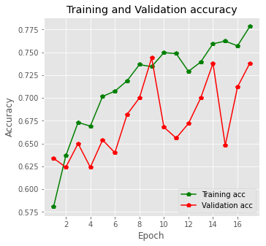

**Figure 5**: Training and Validation Accuracy

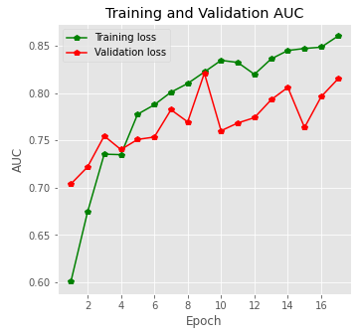

**Figure 6:** Training and Validation AUC

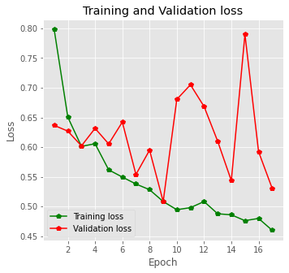

**Figure 7:** Training and Validation loss

# 5 Conclusion

In this study, CNN model VGG-19 was modified in the final layers. VGG-19 is only implemented now. The dataset contains SARS-CoV-2-affected and normal x-ray and CT scan images. The accuracy of the CNN model was 75.82%. Further work will be performed with other pretrained models.

Classification and feature extraction are the models that can estimate the infection of SARS-CoV-2 using a simple X-ray and CT image in the shortest possible time. X-ray technology is currently available and is cost-friendly. Thus, it could be an efficient method for knowing the infection percentage of COVID-19 patients. This method is quick and has no risk of standing in a queue to get the infection rate of COVID-19.

 In the future, we will work on the large dataset and implement more models to get better accuracy.

# References

# Books:

1. S. N. Atluri and S. Shen,“Global weak forms, weighted residuals, finite elements, boundary elements & local weak forms,”in *The Meshless Local Petrov-Galerkin (MLPG) Method,* 1st ed., vol. 1. Henderson, NV, USA: Tech Science Press, pp.15–64,2004.

# Books(Online):

1. McNeil Jr DG (2 February 2020). "Wuhan Coronavirus Looks Increasingly Like a Pandemic, Experts Say".The New York Times. ISSN 0362-4331.Retrieved 4 April 2020. [Online].

Available:https://www.nytimes.com/2020/02/02/health/coronavirus-pandemic-china.html

1. "Novel Coronavirus (2019-nCoV) Situation Report – 1" (PDF). World Health Organization (WHO). 21 January 2020 .[Online].Available : <https://apps.who.int/iris/handle/10665/330760>
2. "Novel Coronavirus(2019-nCoV) Situation Report – 10" (PDF). World Health Organization (WHO). 30 January 2020.

# Conference proceedings (published):

1. Jones, Lora, et al. “Coronavirus: How the pandemic has changed the world economy.” BBC, 24 January 2021, https://www.bbc.com/news/business-51706225.Accessed 6 December 2021.

# Journals:

1. A Li, Chenxi et al. “Laboratory diagnosis of coronavirus disease-2019 (COVID-19).” Clinica chimica acta; international journal of clinical chemistry vol. 510 (2020):35-46. doi:10.1016/j.cca.2020.06.045
2. Coronavirus Disease 2019 (COVID-19): A Systematic Review of Imaging Findings in 919 Patients Sana Salehi, Aidin Abedi, Sudheer Balakrishnan, and Ali Gholamrezanezhad American Journal of Roentgenology 2020 215:1, 87-93
3. J Meem, Anika Tahsin, Mohammad Monirujjaman Khan, Mehedi Masud, and Sultan Aljahdali. "Prediction of Covid-19 Based on Chest X-Ray Images Using Deep Learning with CNN." Computer Systems Science and Engineering (2022): 1223-1240.
4. Uddin, A., Talukder, B., Monirujjaman Khan, M., & Zaguia, A. (2021). Study on Convolutional Neural Network to Detect COVID-19 from Chest X-Rays.Mathematical Problems in Engineering, 2021.
5. Bougourzi, F., Distante, C., Ouafi, A., Dornaika, F., Hadid, A., & Taleb-Ahmed, A. (2021). Per-COVID-19: A Benchmark Dataset for COVID-19 Percentage Estimation from CT-Scans. Journal of Imaging, 7(9), 189.
6. *CodaLab - Competition*. (2021, October 21). Www.Codalab.Org. Retrieved October 26, 2021, from <https://competitions.codalab.org/competitions/35575>
7. F. (2021, October 16). *GitHub - faresbougourzi/Per-Covid-19: Covid-19 infection percentage estimation from CT-scans*. GitHub. <https://github.com/faresbougourzi/Per-Covid-19>
8. O. A. Hamid, L. Deng, D. Yu, ''Exploring convolutional neural network structures and optimization techniques for speech recognition,”*ISCA*,Vol. 11, pp. 73-5, 2013. Available: <https://www.microsoft.com/en-us/research/publication/exploring-convolutional-neural-network-structures-and-optimization-techniques-for-speech-recognition/>
9. J. Brownlee, "A gentle introduction to pooling layers for convolutional neural networks", *Machine Learning Mastery*, 2021 [Online]. Available: https://machinelearningmastery.com/pooling-layers-for-convolutional-neural-networks/
10. J. Jeong, "The most intuitive and easiest guide for CNN," *Medium*, 2021.[Online] Available: <https://towardsdatascience.com/the-most-intuitive-and-easiest-guide-for-convolutional-neural-network-3607be47480>
11. [22,16 will]S. Saha, "A comprehensive guide to convolutional neural networks — the ELI5 way,"*Medium*,2021.[Online].Available:https://towardsdatascience.com/a-comprehensive-guide-to-convolutional-neural-networks-the-eli5-way-3bd2b1164a53
12. [23,17]I. Apostolopoulos and T. Mpesiana, "Covid-19: automatic detection from X-ray images utilizing transfer learning with convolutional neural networks," *Physical and Engineering Sciences in Medicine*, vol. 43, no. 2, pp. 635-640, 2020. [Online]. Available: 10.1007/s13246-020-00865-4

# Appendix A. Example of appendix

_________________________________________________________________

Layer (type) Output Shape Param #

=================================================================

input_1 (InputLayer) [(None, 128, 128, 3)] 0

block1_conv1 (Conv2D) (None, 128, 128, 64) 1792

block1_conv2 (Conv2D) (None, 128, 128, 64) 36928

block1_pool (MaxPooling2D) (None, 64, 64, 64) 0

block2_conv1 (Conv2D) (None, 64, 64, 128) 73856

block2_conv2 (Conv2D) (None, 64, 64, 128) 147584

block2_pool (MaxPooling2D) (None, 32, 32, 128) 0

block3_conv1 (Conv2D) (None, 32, 32, 256) 295168

block3_conv2 (Conv2D) (None, 32, 32, 256) 590080

block3_conv3 (Conv2D) (None, 32, 32, 256) 590080

block3_conv4 (Conv2D) (None, 32, 32, 256) 590080

block3_pool (MaxPooling2D) (None, 16, 16, 256) 0

block4_conv1 (Conv2D) (None, 16, 16, 512) 1180160

block4_conv2 (Conv2D) (None, 16, 16, 512) 2359808

block4_conv3 (Conv2D) (None, 16, 16, 512) 2359808

block4_conv4 (Conv2D) (None, 16, 16, 512) 2359808

block4_pool (MaxPooling2D) (None, 8, 8, 512) 0

block5_conv1 (Conv2D) (None, 8, 8, 512) 2359808

block5_conv2 (Conv2D) (None, 8, 8, 512) 2359808

block5_conv3 (Conv2D) (None, 8, 8, 512) 2359808

block5_conv4 (Conv2D) (None, 8, 8, 512) 2359808

block5_pool (MaxPooling2D) (None, 4, 4, 512) 0

=================================================================

Total params: 20,024,384

Trainable params: 20,024,384

Non-trainable params: 0 _________________________________________________________________